Kanisha Shah

UID: 504958165

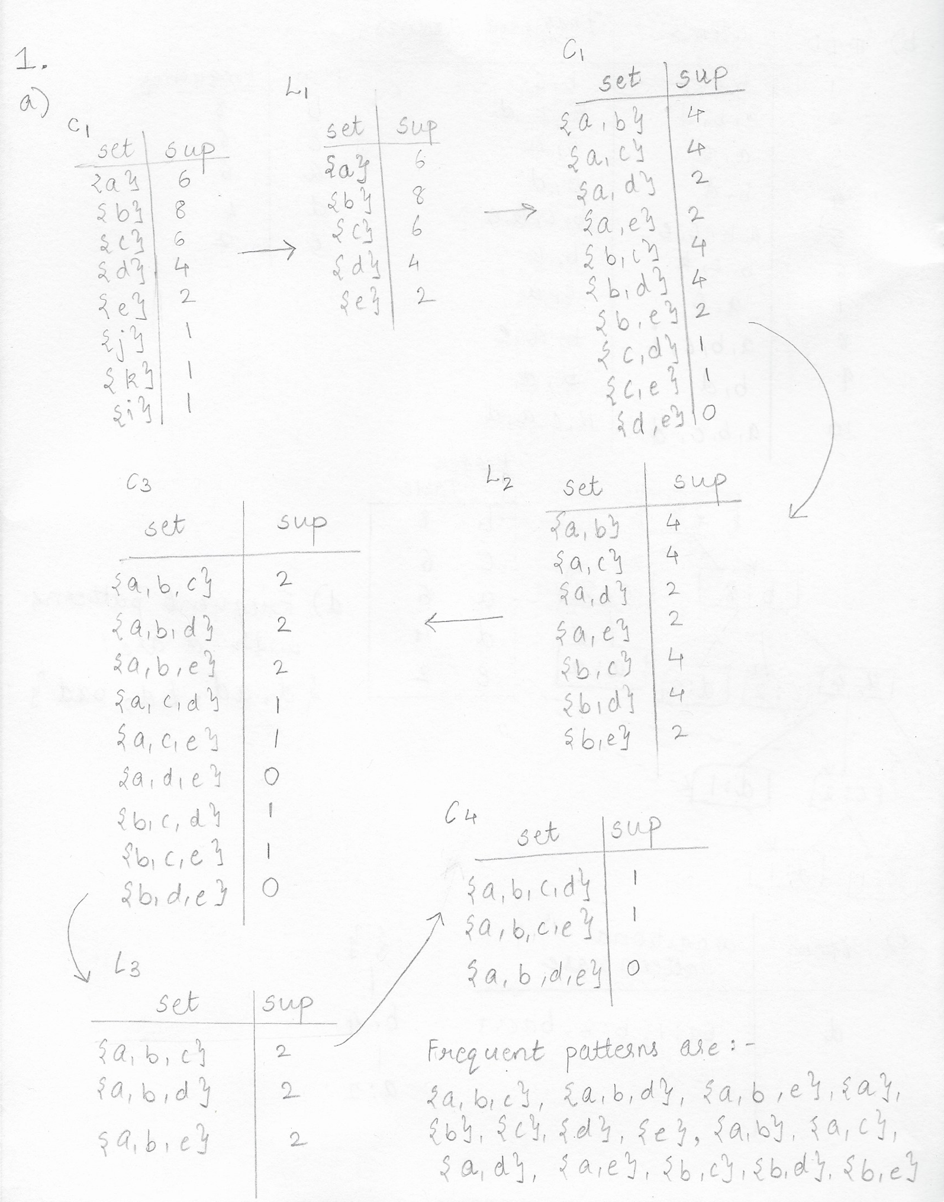

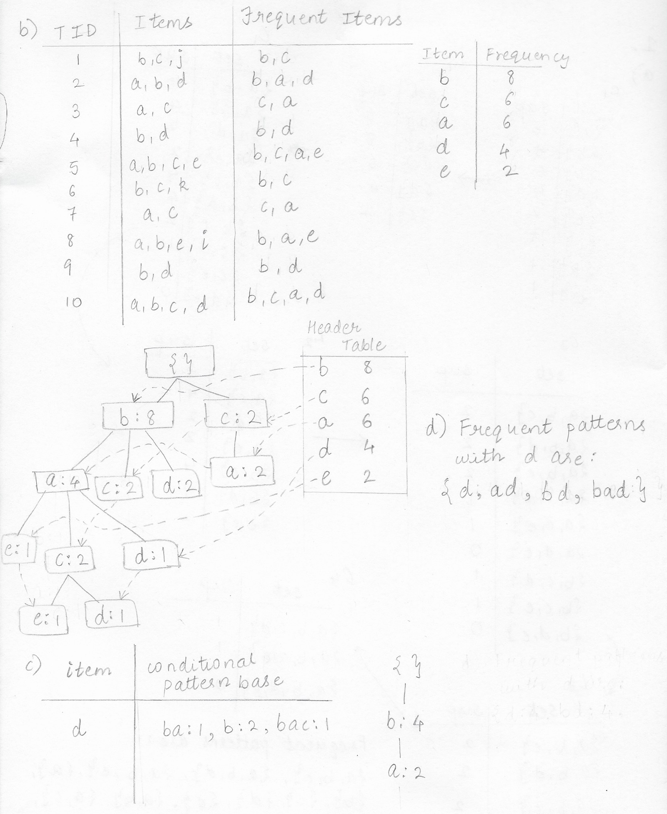

2. Support is the number of reviewers that reviewed all the places in the itemset. For A => B, confidence is the probability that someone who reviews A also reviews B. We can see that businesses with high confidence are also frequent patterns. All the businesses are located in Las Vegas. All the businesses mentioned are restaurants except one hotel: The Cosmopolitan of Las Vegas. All these businesses are at a walking distance from another at the Las Vegas Strip. Since they are so close to one another, there is a high probability that someone who has visited one of them, would also go to another.

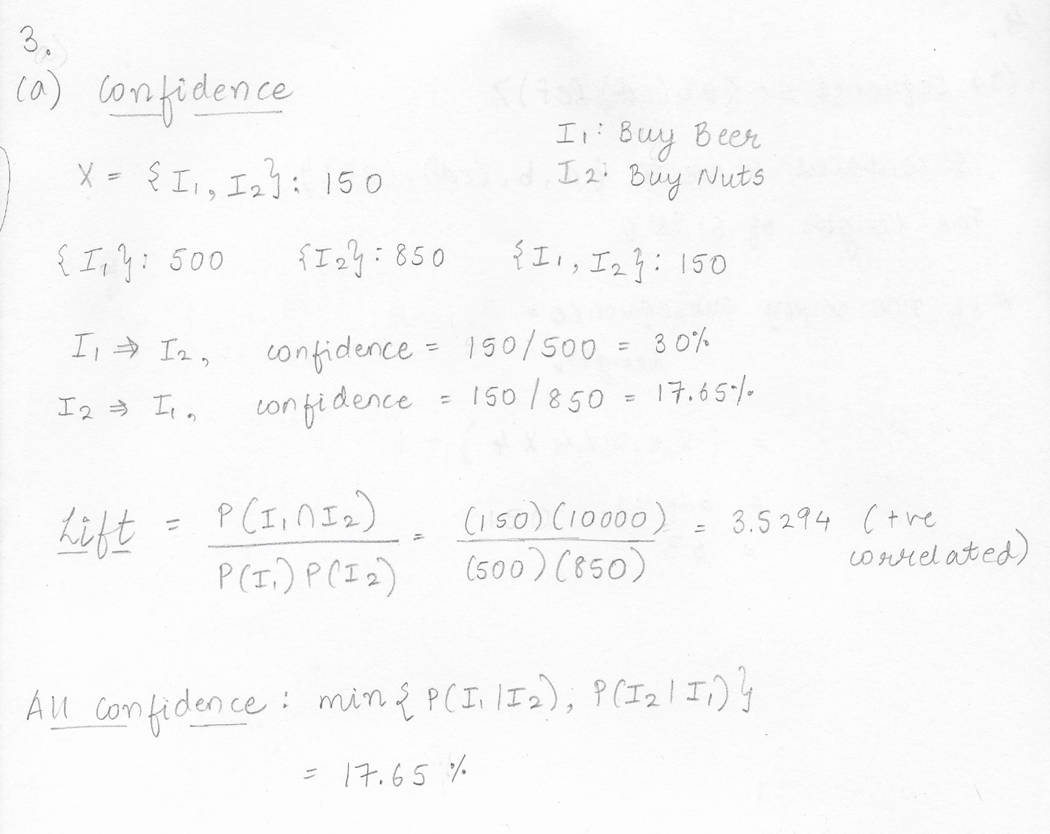

(b) Lift greater than 1 means that the correlation between the two objects is positive. We get a lift of 3.5294 for buying nuts and buying beers. So, there is a positive correlation between buying nuts and beer.

